Little SPM Manual

0. 사전준비

i. PowerShell 실행

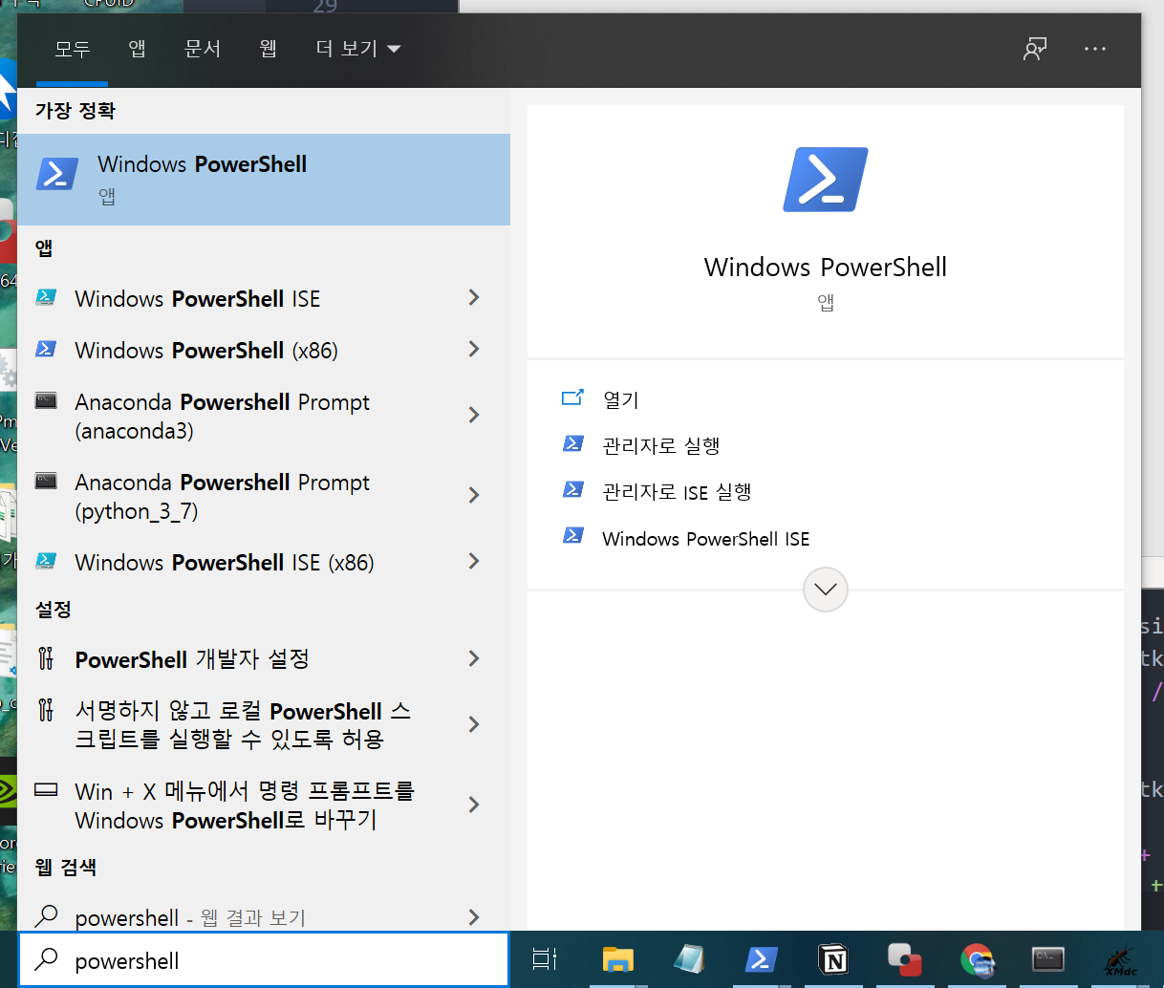

Powershell 초기창

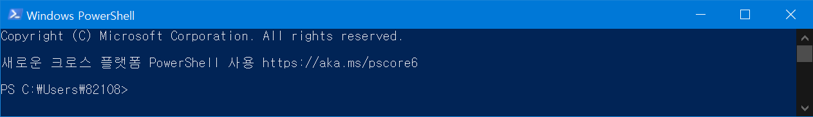

ii. 디렉토리 이동

`cd Desktop/REPO` 입력 (REPO 디렉토리로 이동)

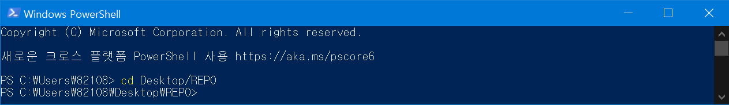

iii. 파일 가져오기

조작하고자 하는 파일이나 폴더를 REPO 폴더에 넣는다.

1. 실행

i. Dicom to Nifti (파일 변환)

input – dicom folder

output – nifti file

python little_spm.py --rotate --directory <sample directory> --angle <degree>

ex) python little_spm.py --rotate -d 15819775_T1 -a 3

ii. Rotate Dicoms

input – dicom folder

output – nifti file

python little_spm.py --convert --directory <sample directory>

ex) python little_spm.py --convert -d 15819775_T1

iii. Image Registration

input – 2 nifti files

output – nifty file and tfm file

python little_spm.py --registration --input <nifti file> --template <nifti file>  
--iterations <numberOfIterations>

ex) python little_spm.py --registration -i 15819775.nii -t BRAIN _ATLAS.nii

사용가능한 템플릿들

* mni_icbm152_t1_sym_09a.nii
* mni_icbm152_t1_sym_09c.nii
* mni_icbm152_t2_sym_09c.nii
* BRAIN_ATLAS.nii
* SPM/PET.nii
* SPM/SPECT.nii
* SPM/T1.nii
* SPM/T2.nii

iv. Brain Smoothing

input – nifti file

output – nifti file

python little_spm.py --smoothing --input <nifti file> --fwhm <fwhm>

ex) python little_spm.py --smoothing -i 15819775_T1.nii -f 8

v. Brain Extraction (Only run in Linux)

input – nifti file

output – 2 nifti files

python little_spm.py --extract --input <nifti file>

ex) python little_spm.py --extract -i 15819775_T1.nii

vi. Normalization

input – nifti file

output – nifti file

python little_spm.py --normalize --input <nifti file>

ex) python little_spm.py --normalize -i 15819775_T1.nii

vii. Resize

input – nifti file

output – nifti file

python little_spm.py --resize --input <nifti file> -x <x> -y <y> -z <z>

ex) python little_spm.py --normalize -i 15819775_T1.nii -x 160 -y 190 -z 224

# 변환된 nifti 파일 보기

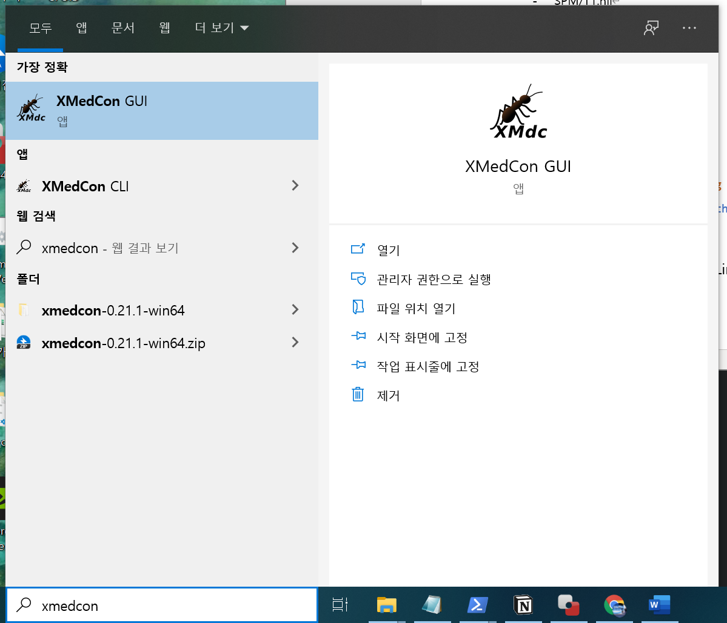

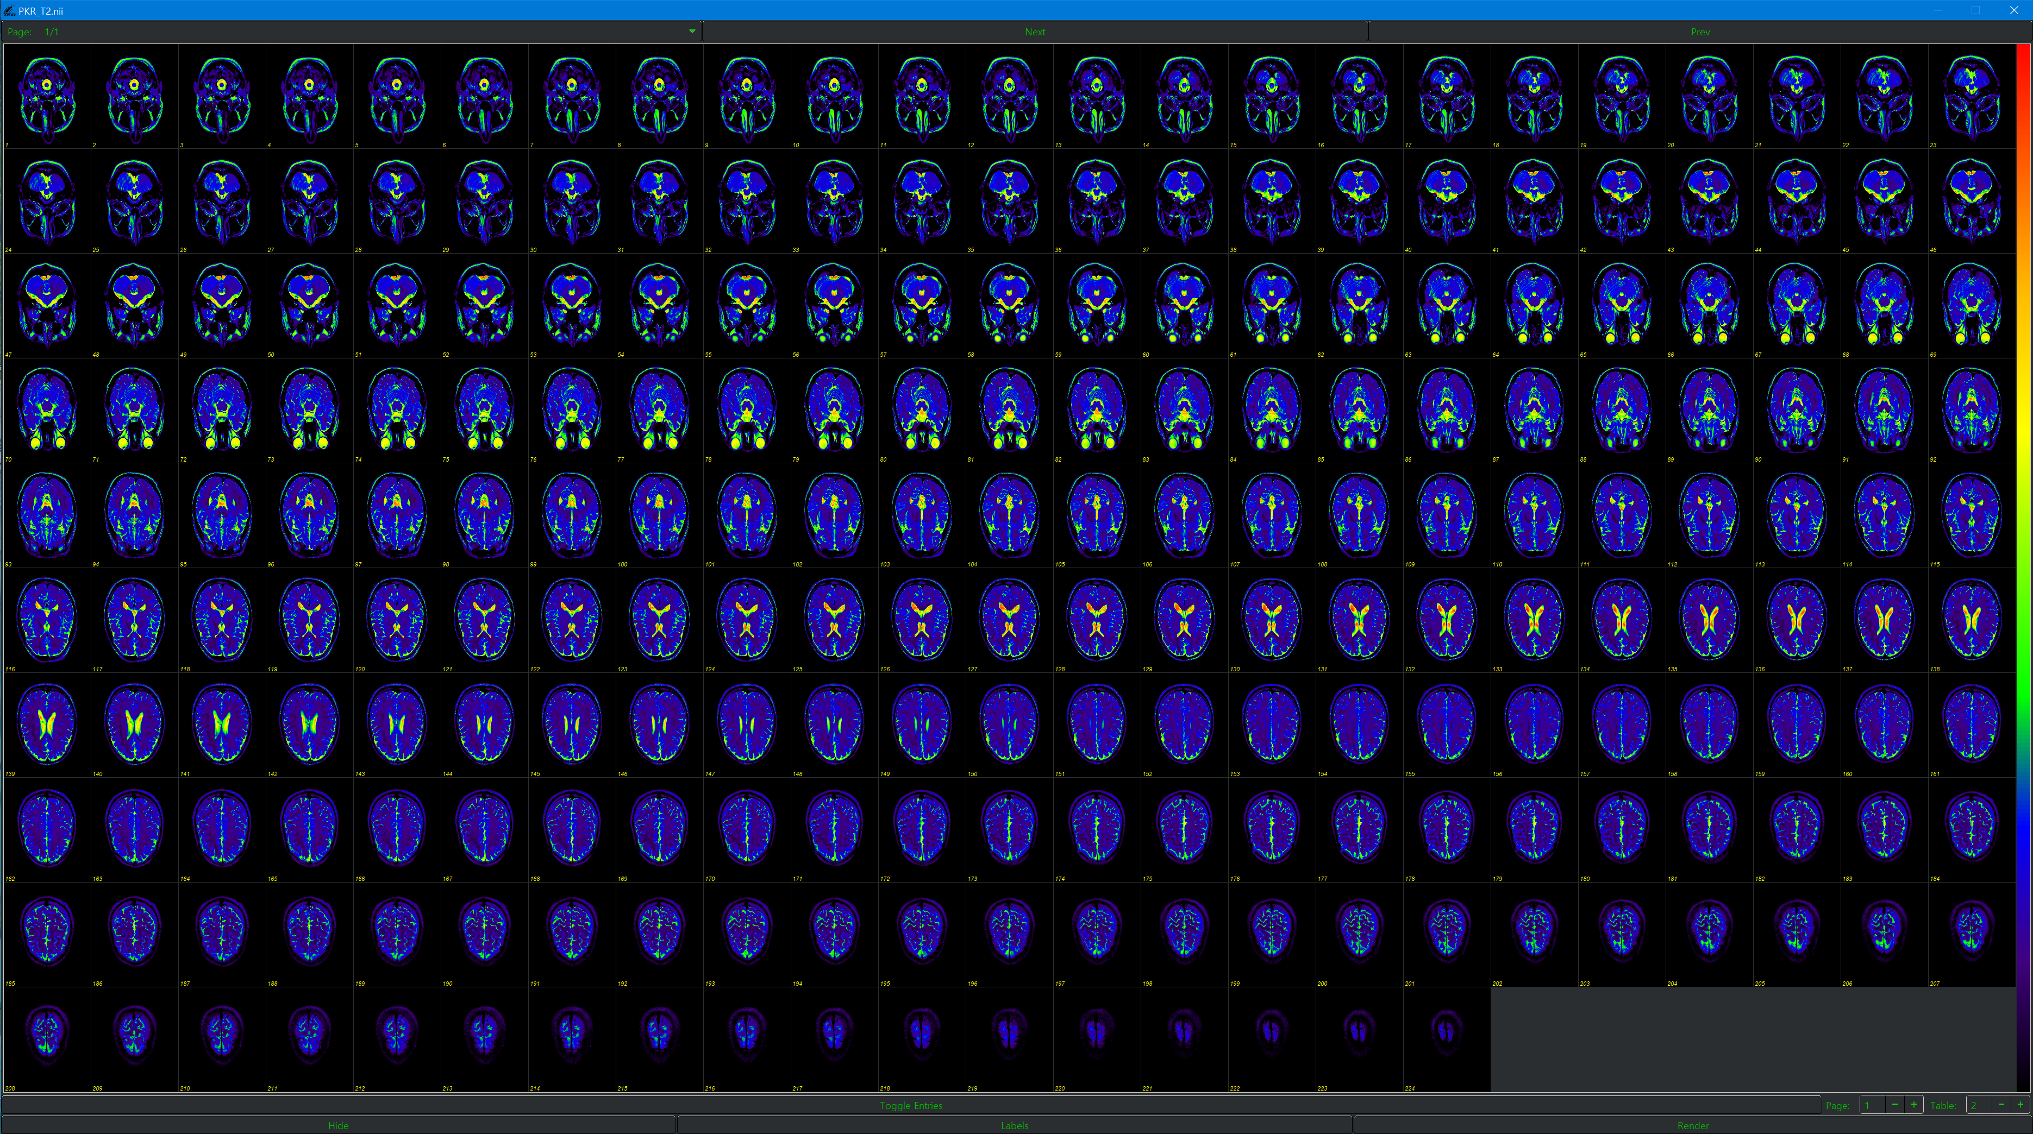

Or

Nii viewer (web)

https://socr.umich.edu/HTML5/BrainViewer/